

**Tech Saksham**

Case Study Report

Data Analytics with Power BI

**“Supply Chain Analysis of**

**Inventories”**

**“Sacred Heart college of Arts and Science**

**Dindigul ”**

|  |  |
| --- | --- |
| **NM ID** | **NAME** |

75C9BE8909FAEFCA2E44

E661CB04E077 Karthik.K

|  |  |
| --- | --- |
| Trainer name | Master name |
|  |  |
| **R.UMAMAGESHWAR** | **R.UMAMAGESHARI** |
| **I** |  |





**ABSTRACT**

Online food ordering systems are designed to cater primarily to the food delivery industry, providing a seamless platform for hotels and restaurants to expand their reach and increase their online presence. These systems enable customers to browse menus and select their desired items quickly, facilitating efficient ordering processes. In the modern food industry, such platforms play a crucial role in ensuring swift and convenient delivery to customers' locations. Restaurant employees leverage user-friendly interfaces to manage orders effectively, resulting in improved customer satisfaction and business growth.



# INDEX

|  |  |  |
| --- | --- | --- |
| **Sr. No.** | **Table of Contents** | **Page No.** |
|  |  |  |
| 1 | Chapter 1: Introduction | 4 |
|  |  |  |
| 2 | Chapter 2: Services and Tools Required | 5 |
|  |  |  |
| 3 | Chapter 3: Project Architecture | 6 |
|  |  |  |
| 4 | Chapter 4: Modeling and Result | 8 |
|  |  |  |
| 5 | Conclusion | 16 |
|  |  |  |
| 6 | Future Scope | 18 |
|  |  |  |
| 7 | References | 19 |
|  |  |  |
| 8 | Links | 20 |
|  |  |  |



**CHAPTER 1**

**INTRODUCTION**

**1.1 Problem Statement**

In today’s competitive product landscape, understanding customer behavior and preferences is crucial for customer retention and revenue generation. However, products often face challenges in analyzing customer data due to the sheer volume and velocity of data generated. Traditional data analysis methods are time-consuming and often fail to provide supply chain insights. This lack of supply chain analysis can lead to missed opportunities for customer engagement, cross-selling, and up-selling, impacting the product’s revenue generation and customer satisfaction. Furthermore, the complexity and diversity of customer data, which includes transaction history, customer feedback, and demographic data, pose additional challenges for data analysis.

**1.2 Proposed Solution**

The proposed solution is to develop a PowerBI dashboard that can analyze and visualize real-time customer data. The dashboard will integrate data from various sources such as transaction history, customer feedback, and demographic data. It will provide a comprehensive view of customer behavior, preferences, and trends, enabling banks to make informed decisions. The dashboard will be interactive, user-friendly, and customizable, allowing products to tailor it to their specific needs. The supply chain analysis capability of the dashboard will enable banks to respond promptly to changes in customer behavior or preferences, identify opportunities for cross-selling and up-selling, and tailor their products and services to meet customer needs.

**1.3 Feature**

* **Supply Chain Analysis**: The dashboard will provide supply chain analysis of customer data.
* **Customer Segmentation**: It will segment customers based on various parameters like age,income, transaction behavior, etc.

**© Edunet Foundation. All rights reserved** |4

* **Trend Analysis**: The dashboard will identify and display trends in customer behavior.
* **Predictive Analysis**: It will use historical data to predict future customer behavior.

**1.4 Advantages**

* **Data-Driven Decisions**: products can make informed decisions based on supply chain dataanalysis.
* **Improved Customer Engagement**: Understanding customer behavior and trends can help toengage with their customers more effectively.
* **Increased Revenue**: By identifying opportunities for cross-selling and up-selling, market canincrease their revenue.

**1.5 Scope**

The scope of this project extends to all banking institutions that aim to leverage data for decision-making and customer engagement. The project can be further extended to incorporate more data sources and advanced analytics techniques, such as machine learning and artificial intelligence, to provide more sophisticated insights into customer behavior. The project also has the potential to be adapted for other sectors, such as retail, healthcare, and telecommunications, where understanding customer behavior is crucial. Furthermore, the project contributes to the broader goal of digital transformation in the product market sector, promoting efficiency, innovation, and customer-centricity.

**CHAPTER 2**

**SERVICES AND TOOLS REQUIRED**

**2.1 Services Used**

**© Edunet Foundation. All rights reserved** |5



* **Data Collection and Storage Services**: product need to collect and store customer datain supply chain. This could be achieved through services like Azure Data Factory, Azure Event Hubs, or AWS Kinesis for real-time data collection, and Azure SQL Database or AWS RDS for data storage.
* **Data Processing Services**: Services like Azure Stream Analytics or AWS Kinesis DataAnalytics can be used to process the real-time data.
* **Machine Learning Services**: Azure Machine Learning or AWS SageMaker can beused to build predictive models based on historical data.

**2.2 Tools and Software used**

**Tools**:

* **PowerBI**: The main tool for this project is PowerBI, which will be used to createinteractive dashboards for real-time data visualization.
* **Power Query**: This is a data connection technology that enables you to discover,connect, combine, and refine data across a wide variety of sources.

**Software Requirements**:

* **PowerBI Desktop**: This is a Windows application that you can use to create reportsand publish them to PowerBI.
* **PowerBI Service**: This is an online SaaS (Software as a Service) service that you useto publish reports, create new dashboards, and share insights.
* **PowerBI Mobile**: This is a mobile application that you can use to access your reportsand dashboards on the go.

**© Edunet Foundation. All rights reserved** |6

**CHAPTER 3**

**PROJECT ARCHITECTURE**

**3.1 Architecture**

Here’s a high-level architecture for the project:

1. **Data Collection**: supply chain customer data is collected from various sources likeproduct transactions, customer interactions, etc. This could be achieved using services like Azure Event Hubs or AWS Kinesis.
2. **Data Storage**: The collected data is stored in a database for processing. Azure SQLDatabase or AWS RDS can be used for this purpose.
3. **Data Processing**: The stored data is processed in real-time using services like AzureStream Analytics or AWS Kinesis Data Analytics.
4. **Machine Learning**: Predictive models are built based on processed data using AzureMachine Learning or AWS SageMaker. These models can help in predicting customer behavior, detecting fraud, etc.
5. **Data Visualization**: The processed data and the results from the predictive models arevisualized in real-time using PowerBI. PowerBI allows you to create interactive dashboards that can provide valuable insights into the data.
6. **Data Access**: The dashboards created in PowerBI can be accessed through PowerBIDesktop, PowerBI Service (online), and PowerBI Mobile.

This architecture provides a comprehensive solution for real-time analysis of bank customers. However, it’s important to note that the specific architecture may vary depending on the bank’s existing infrastructure, specific requirements, and budget. It’s also important to ensure that all tools and services comply with relevant data privacy and security regulations.

**© Edunet Foundation. All rights reserved** |7



**CHAPTER 4**

**MODELING AND RESULT**

**Manage relationship**

The “disp” file will be used as the main connector as it contains most key identifier (account id, client id and disp id) which can be use to relates the 8

**© Edunet Foundation. All rights reserved** |8

data files together. The “district” file is use to link the client profile

geographically with “district id”

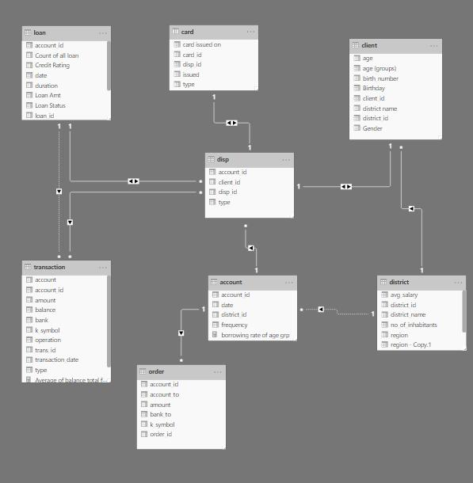

**© Edunet Foundation. All rights reserved** |9

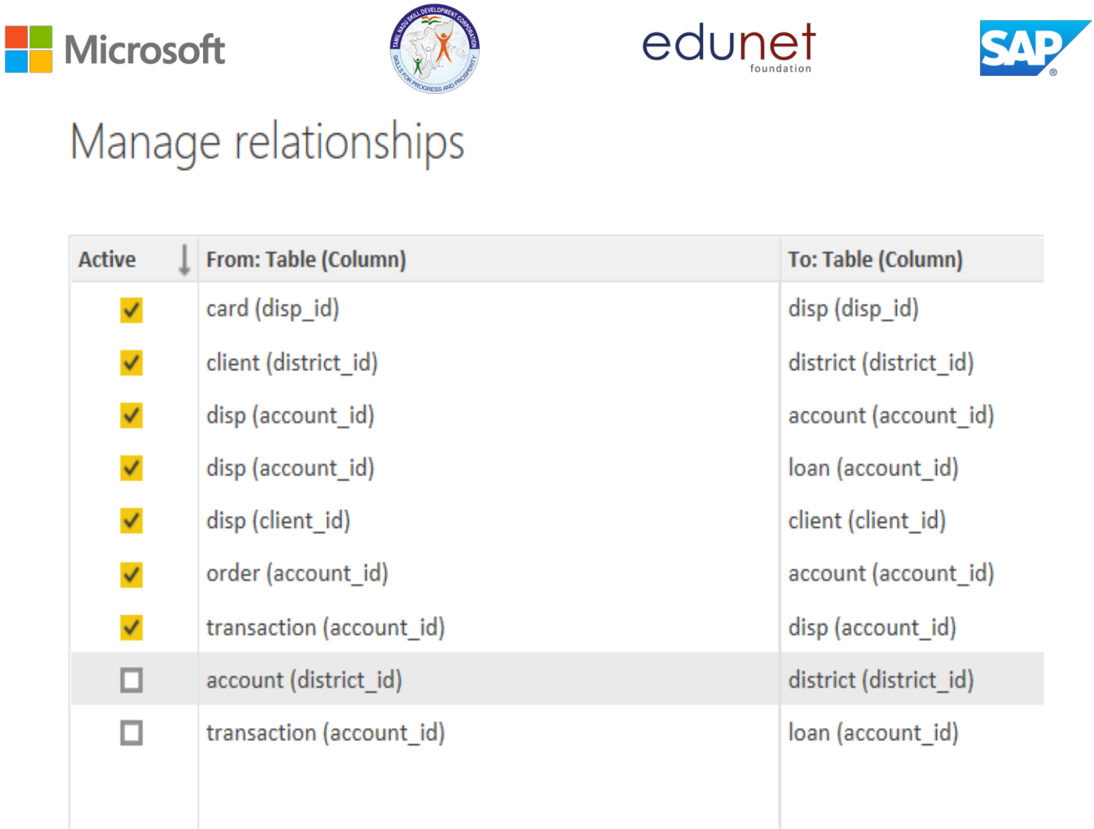

**© Edunet Foundation. All rights reserved** |10

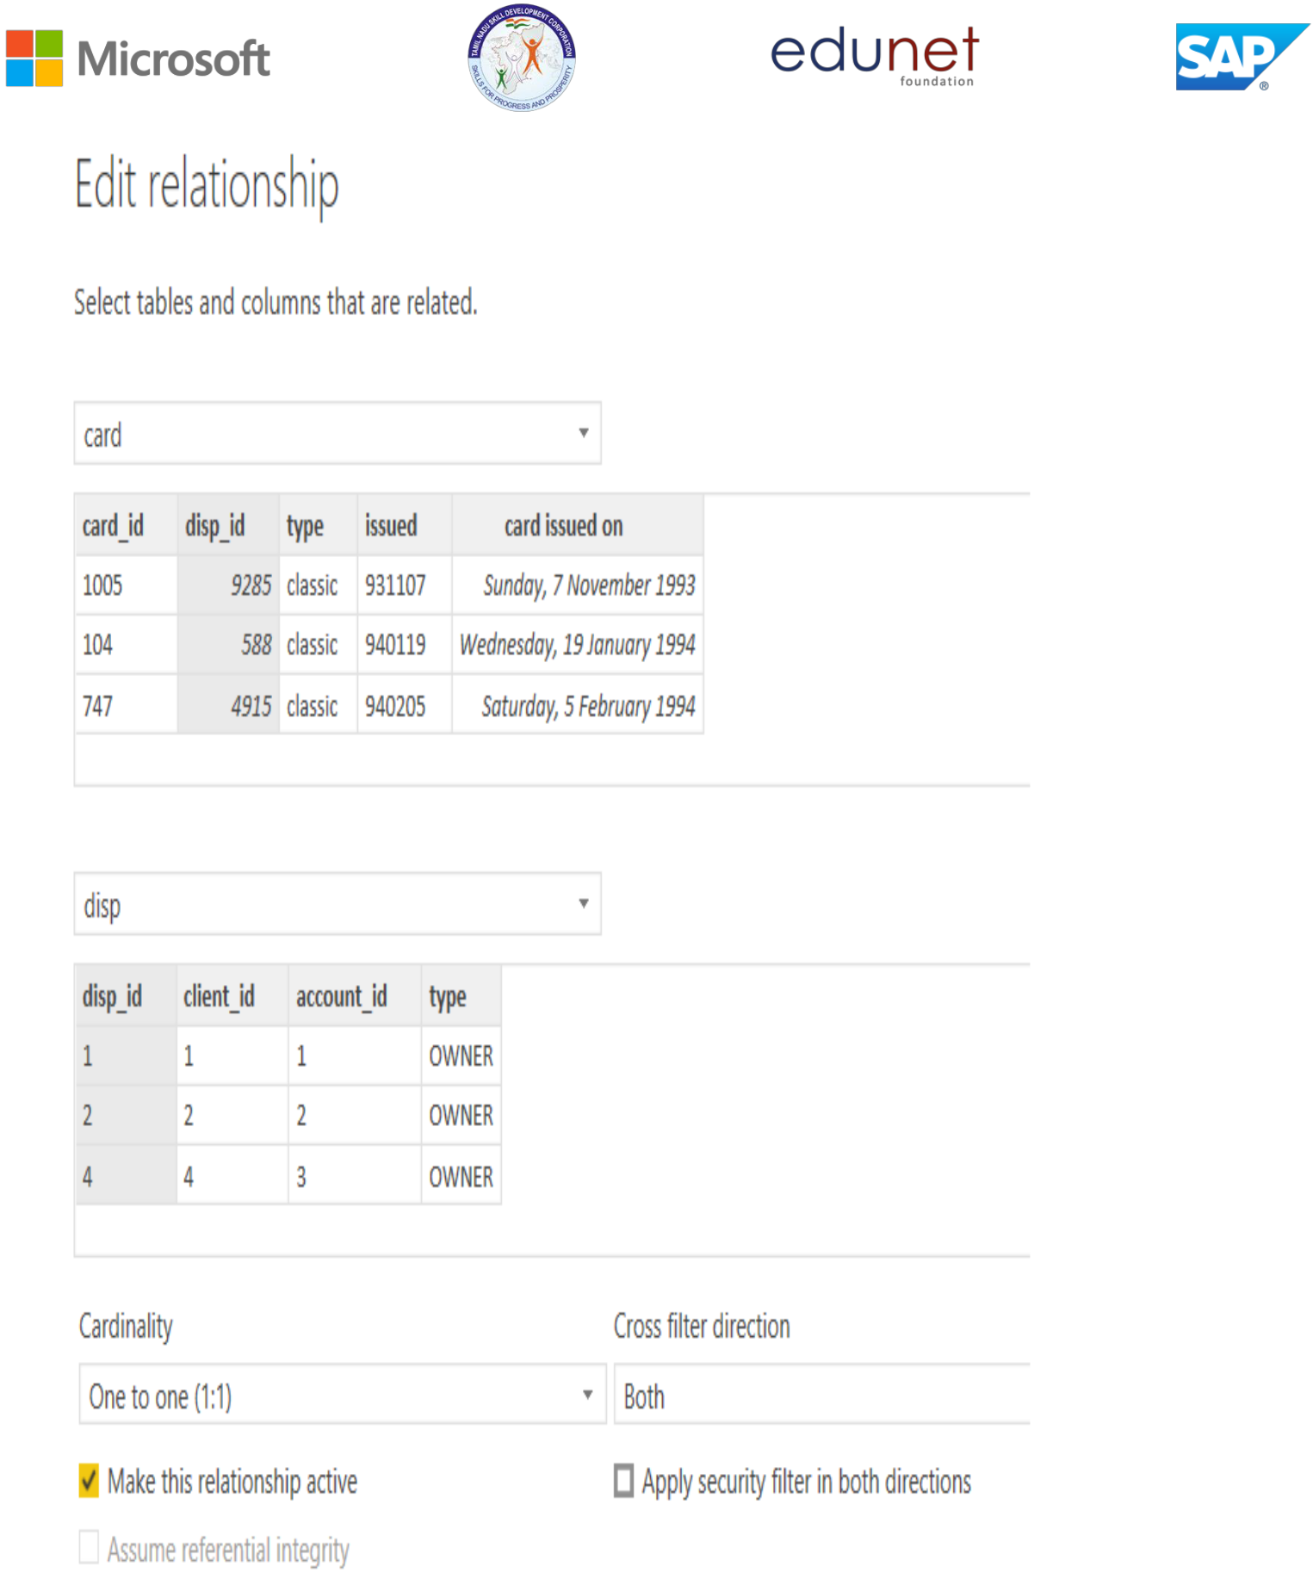

**Modelling for Gender and Age data**

Notice that the Gender and age of the client are missing from the data. These can be formulated from the birth number YYMMDD where at months (the 3rd

**© Edunet Foundation. All rights reserved** |11



and 4th digits) greater than 50 means that client is a Female. We can create a column for Gender.

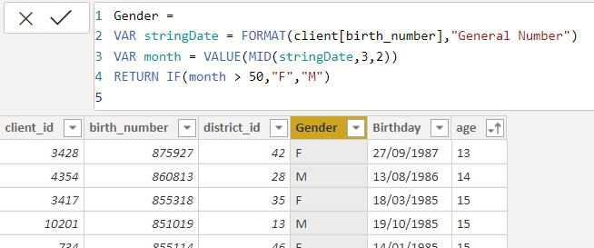

For birthday, we need to reduce the birth month of the female by 50 and then change the date format to DD/MM/YYYY adding 1900 to the year.

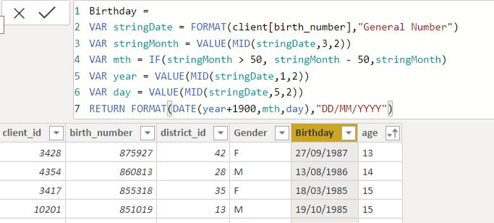

For Age, we shall assume it is year 1999 as explain previously and use it to minus from the birth year.

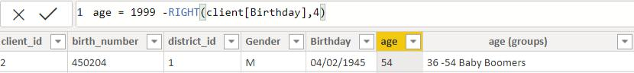

**Replacing values**

**© Edunet Foundation. All rights reserved** |12



Set some fields to English for easy understanding, we replace values to English with the Power Query Editor.

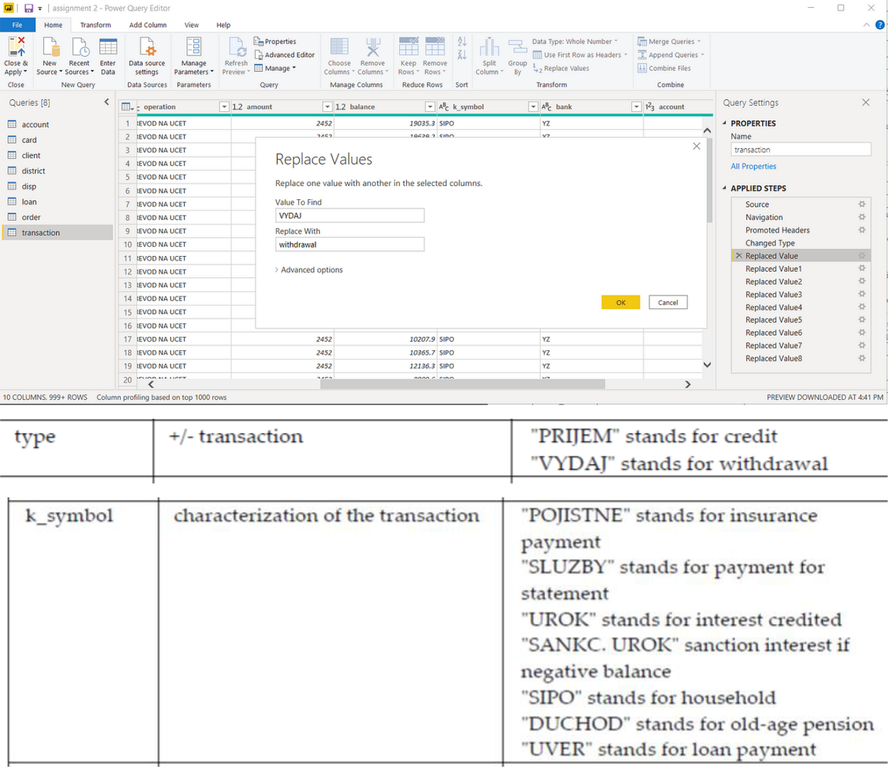

Changing the order of Region name at Power Query

Duplicate the “district /region” then split column using space as delimiter.

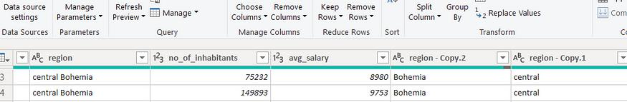

Then merge column by Region and direction. Refer to applied steps for details.

**© Edunet Foundation. All rights reserved** |13

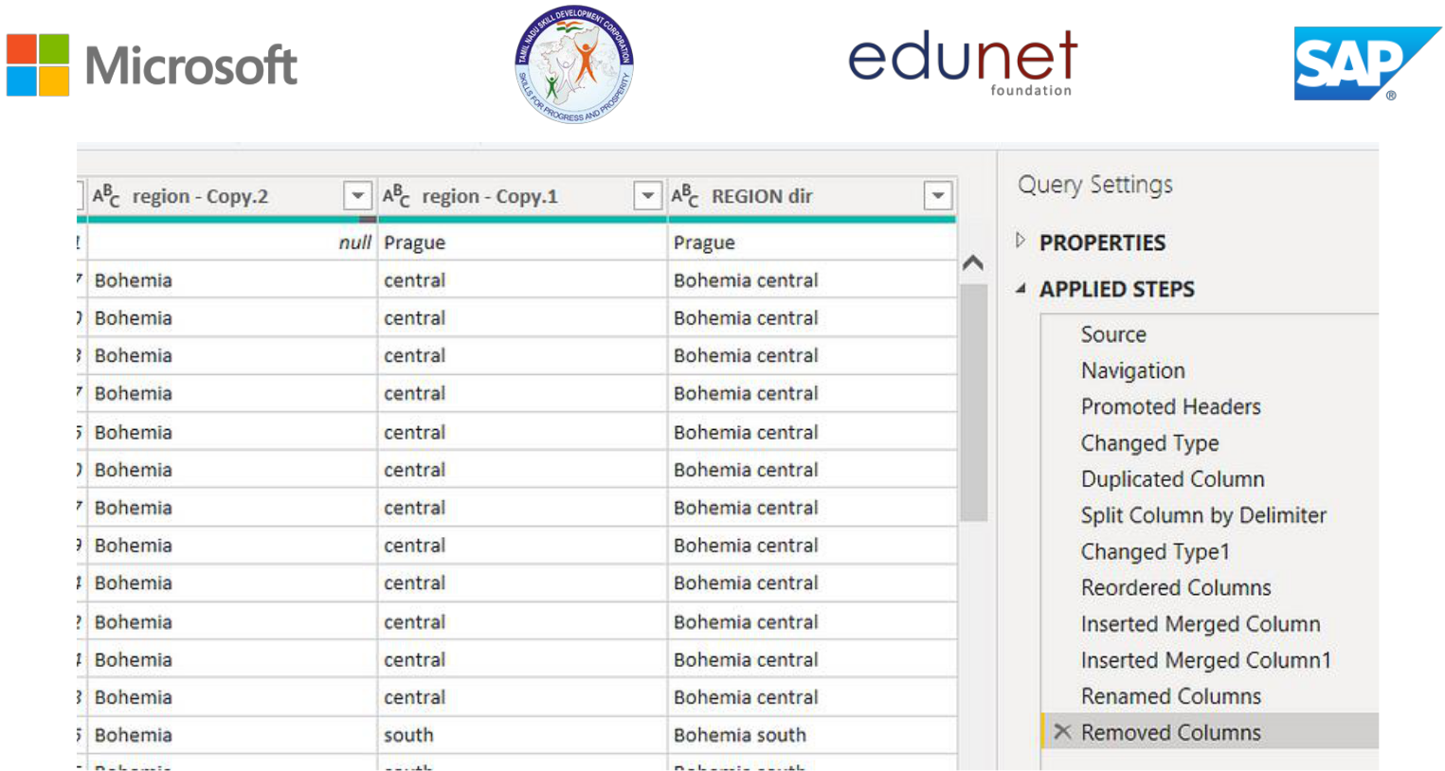

**Grouping of age by ranges**

As the customers’ age ranges from 12 to 88, we shall group them into different generation age range for easier profiling, we will group the ages into 5 groups. The Gen Y are youths,

Gen X are young working adults, some starting their families Baby Boomer are working adults with families.

The silent Generations some are working and retired, living on pensions.

The greatest Generation, retired elderly living on pensions.

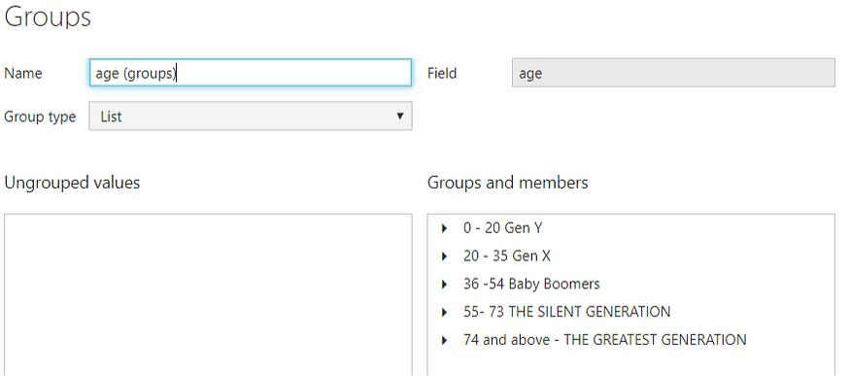

**Credit Rating and Loan Status**

**© Edunet Foundation. All rights reserved** |14



As the Loan status uses A, B, C, D which are not reader friendly. We can add a column to represent what it stands for, we also simplify the classification of those with late or default on payment as bad credit, refer to the table below for details on the new columns added.

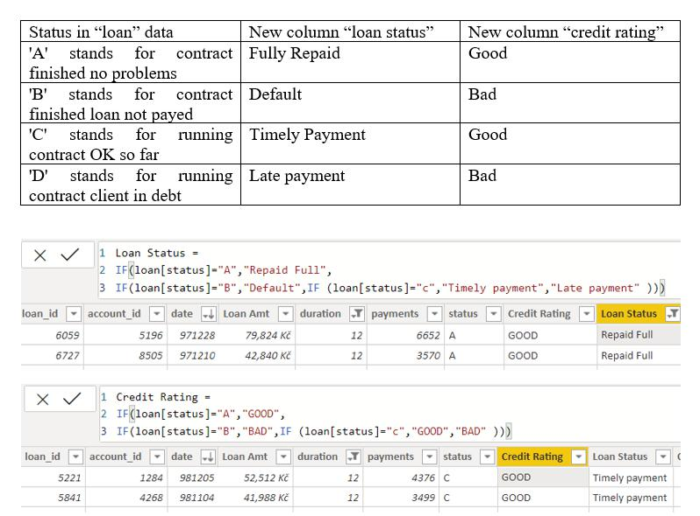

Values of such as “account Id” have also been set as Text.

And District name have been categorized as place to be use for the map to show the sum of the inhabitants in each region.

**© Edunet Foundation. All rights reserved** |15

## Dashboard

## C:\Users\K.Karthik 3K\Downloads\IMG-20240328-WA0005 (1).jpg

**CONCLUSION**

In today's dynamic landscape, the conventional approach of dining out has witnessed a marked decline, largely overshadowed by the pervasive influence of technology in shaping our daily lives. This paradigm shift towards digitalization has ushered in an era where convenience, speed, and safety reign supreme in accessing a plethora of services. At the forefront of this evolution lies the Online Food Ordering System project, an innovative endeavor aimed at meeting the evolving needs of the restaurant industry.

This project represents a paradigm shift in the way customers interact with dining establishments, offering a seamless and intuitive platform for ordering food online. By harnessing the power of software and technological devices, the system seeks to streamline the entire ordering process, thereby minimizing exceptions and ensuring swift and secure access to a wide array of culinary delights.

One of the key pillars of this project is its emphasis on providing customers with an effortless and expedited ordering experience. Through a user-friendly interface, patrons can effortlessly peruse menus, place orders, and even customize their selections to suit their preferences. This not only enhances the overall convenience of the dining experience but also empowers customers with greater control over their culinary choices.

Moreover, the project is designed to facilitate seamless communication and data flow between customers and restaurants, thereby minimizing misunderstandings and errors. By enabling users to easily modify essential profile information, such as delivery addresses and contact numbers, the system ensures that orders are accurately processed and delivered to the right location in a timely manner.

Beyond its practical utility, the Online Food Ordering System project embodies a broader ethos of customer satisfaction and operational efficiency. By reducing time wastage, eliminating potential points of friction, and providing a platform for seamless transactions, the project aims to elevate the overall dining experience for both customers and restaurant staff alike.

In essence, the project represents a convergence of technology and gastronomy, where innovation and convenience converge to redefine the way we interact with food establishments. Through its focus on ease of use, reliability, and customer satisfaction, the Online Food Ordering System project stands as a testament to the transformative power of technology in shaping the future of the restaurant industry.



**© Edunet Foundation. All rights reserved** |17

**FUTURE SCOPE**

The future scope of this project is promising, with potential integration of advanced analytics and machine learning through tools like Power BI. This could enable the bank to predict customer needs and offer proactive solutions. Additionally, robust data governance strategies will ensure secure handling of sensitive information, while real-time data integration could revolutionize customer interactions, boosting satisfaction and loyalty.

**© Edunet Foundation. All rights reserved** |18

**REFERENCES**

https://en.wikipedia.org/wiki/Product_management

**© Edunet Foundation. All rights reserved** |19



**LINK**

<https://github.com/Karthik7530/Supply-chain-analysis-of-Inventories>

**© Edunet Foundation. All rights reserved** |20